COMP S362F

Concurrent and networking Programming

Name: Yau Yuen Fung

Student ID: 12336870

GitHub: <https://github.com/ewenyau123/362F-project>

Technology / Technique

Benefit and Feature Table

|  |  |  |  |
| --- | --- | --- | --- |
| Technology / Technique | Benefit / Feature | File name | Lines |
| Timeout with Simple cookie | Inactive shopping session will be expired with 60 seconds | Server.py | 134-136  158-159  166-169 |
| Mysql | Connect to database and set cursor for executing SQL with different situation | Server.py | 17-23  130-131  227-228  261-263  307-311 |
| Os.path | When the request needs to get the specific files, the server will pass the file with safety method. And use the os.path to find the file and pass to the client | Server.py | 25  57  59-71 |
| Threading TCP server | Using the threading to handle the request from the client | Server.py | 334-336 |
| http server handler | Use HTTP request handler to handle different request from the client. Such as get, post.  The do_get() method will handle all the get request. The do_post() method will handle all the post request.  In these methods, they have different method to handle different path. | Server.py | BaseHTTPRequestHandler:  27  do_get():  43-57  do_post():  73-81 |
| header setting | Setting the header with content type, cookies, response, redirect to other locations.  Setting the header to handle different path and request. | Server.py | 29-32  65-66  88  91  104  112  132-138  186-189  199-201  268-280  285-287  312-329 |
| Jinja2 for rendering the html | Using jinja2 to render to html with data which I want to pass into the html. I mainly use it for rendering the product table, rendering the shopping, selection option,  Input id, etc | Server.py | 84-89  92-97  100-105  108-113  140-144  193-197  288-292  312-329 |
|  |  | list.html  listcart.html  addstock.html | 140-149  22,34-42  25-27 |
| Unquote | Get the post data from the header content is encoded and formatted into URL. Thus, I need to change the data into information which is usable. | Server.py | 150 |
| Parse_qs  Encode  decode | Get the post data with form. Using the function rfile.read with return the data which is unreadable. Using parse_qs and encode/decode method to change the data into information and handle it. | Server.py | 208-225  297-306 |
| Check credit card function | Check the credit card. Is it correct with correct vendor?  Check the expired date on the card. Is it expired | Server.py | 229-255 |
| Calculate the cart subtotal and total  Read Cart data from cookie | Read the cart data from the data. It needs to decode and use the split and split into useful array with data I need to use, and I can use.  After read cart data from cookie, using the data from database and calculate the subtotal and total. Then, put the information and the subtotal and total into the array. And use the subtotal array to render client shopping cart detail | Server.py | 148-184 |
| Check the quantity is enough or not for the bill from customer | When the customer checks out the shopping cart, the server will check the number of stock is enough or not for this bill. If enough, the server will check the credit and update the database. If not it will return the not enough message to the client. | Server.py | 256-280 |

Screen Capture of the automatic testing tools

For the automatic testing, I used selenium to test my program.

Running test_shopping_customer.py

Login:

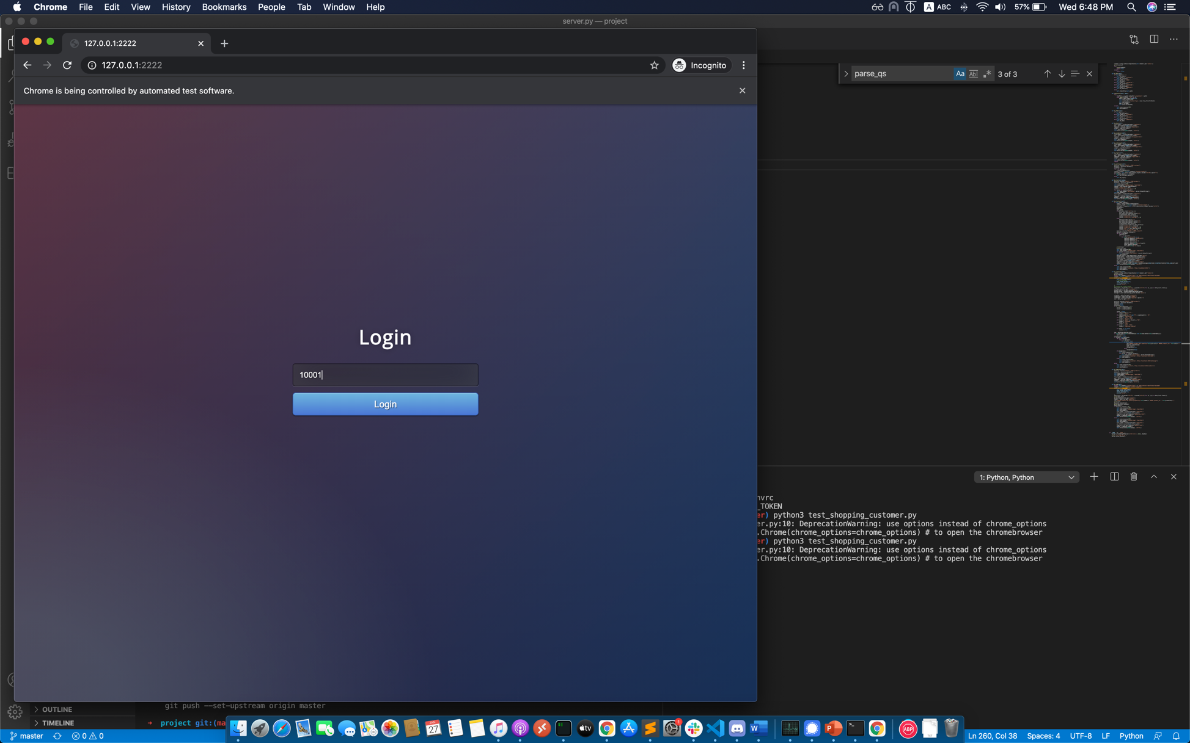

Input 5 in the first unit box

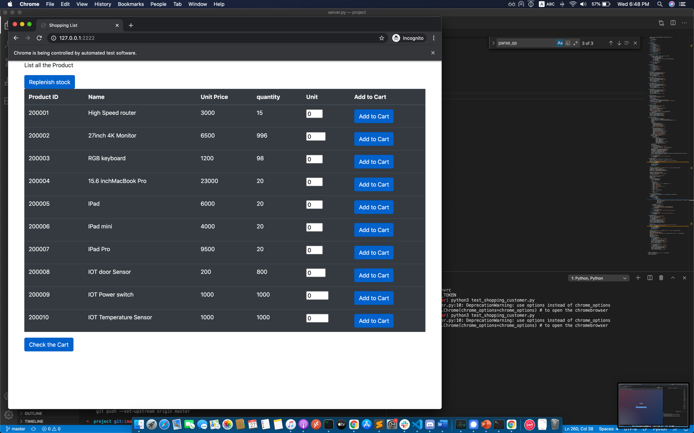

Click the check out button

It will list the Cart

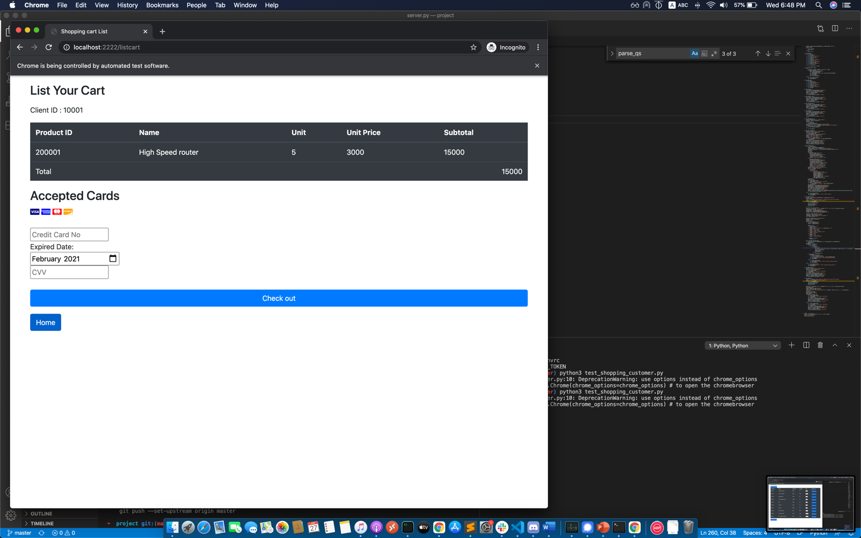

After input the credit card detail.

If the credit card no is correct, it will the thank you message.

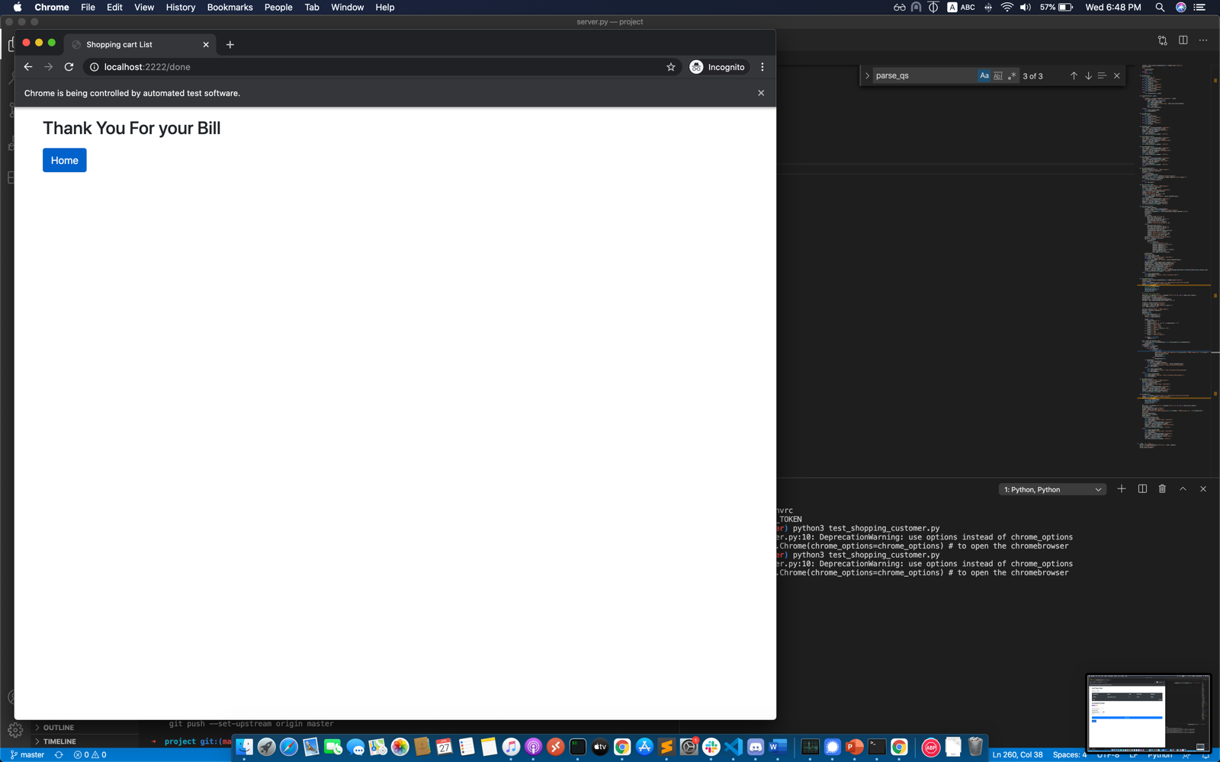

Then, press the home button. It will redirect to login page

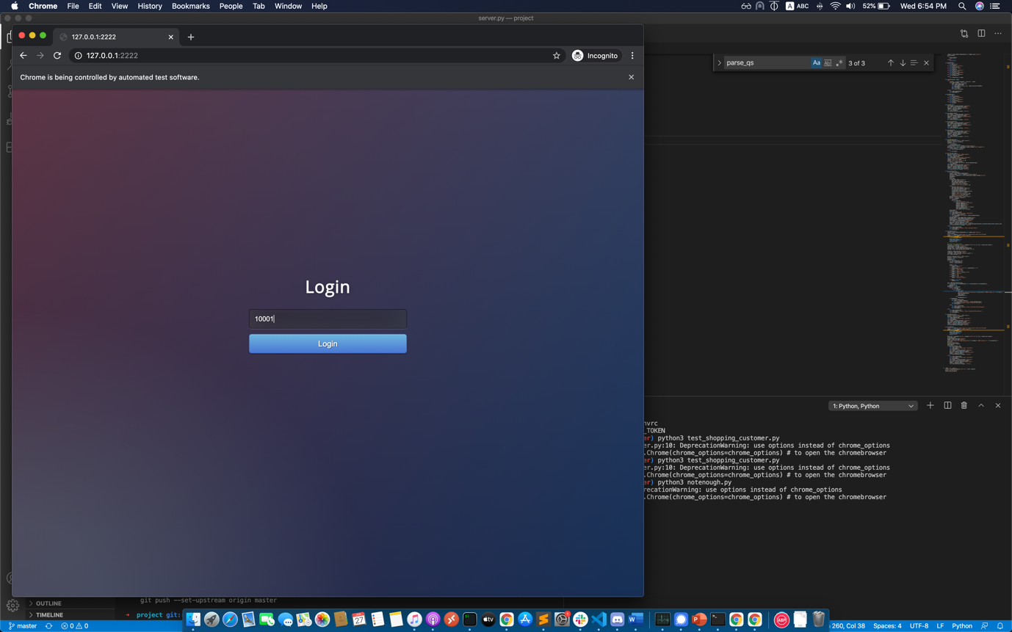

Running the notenough.py

It will test the case with not enough inventory and the customer‘s bill need more the quantity the shop have.

Login:



Input 15 in the first input box and click add to cart button

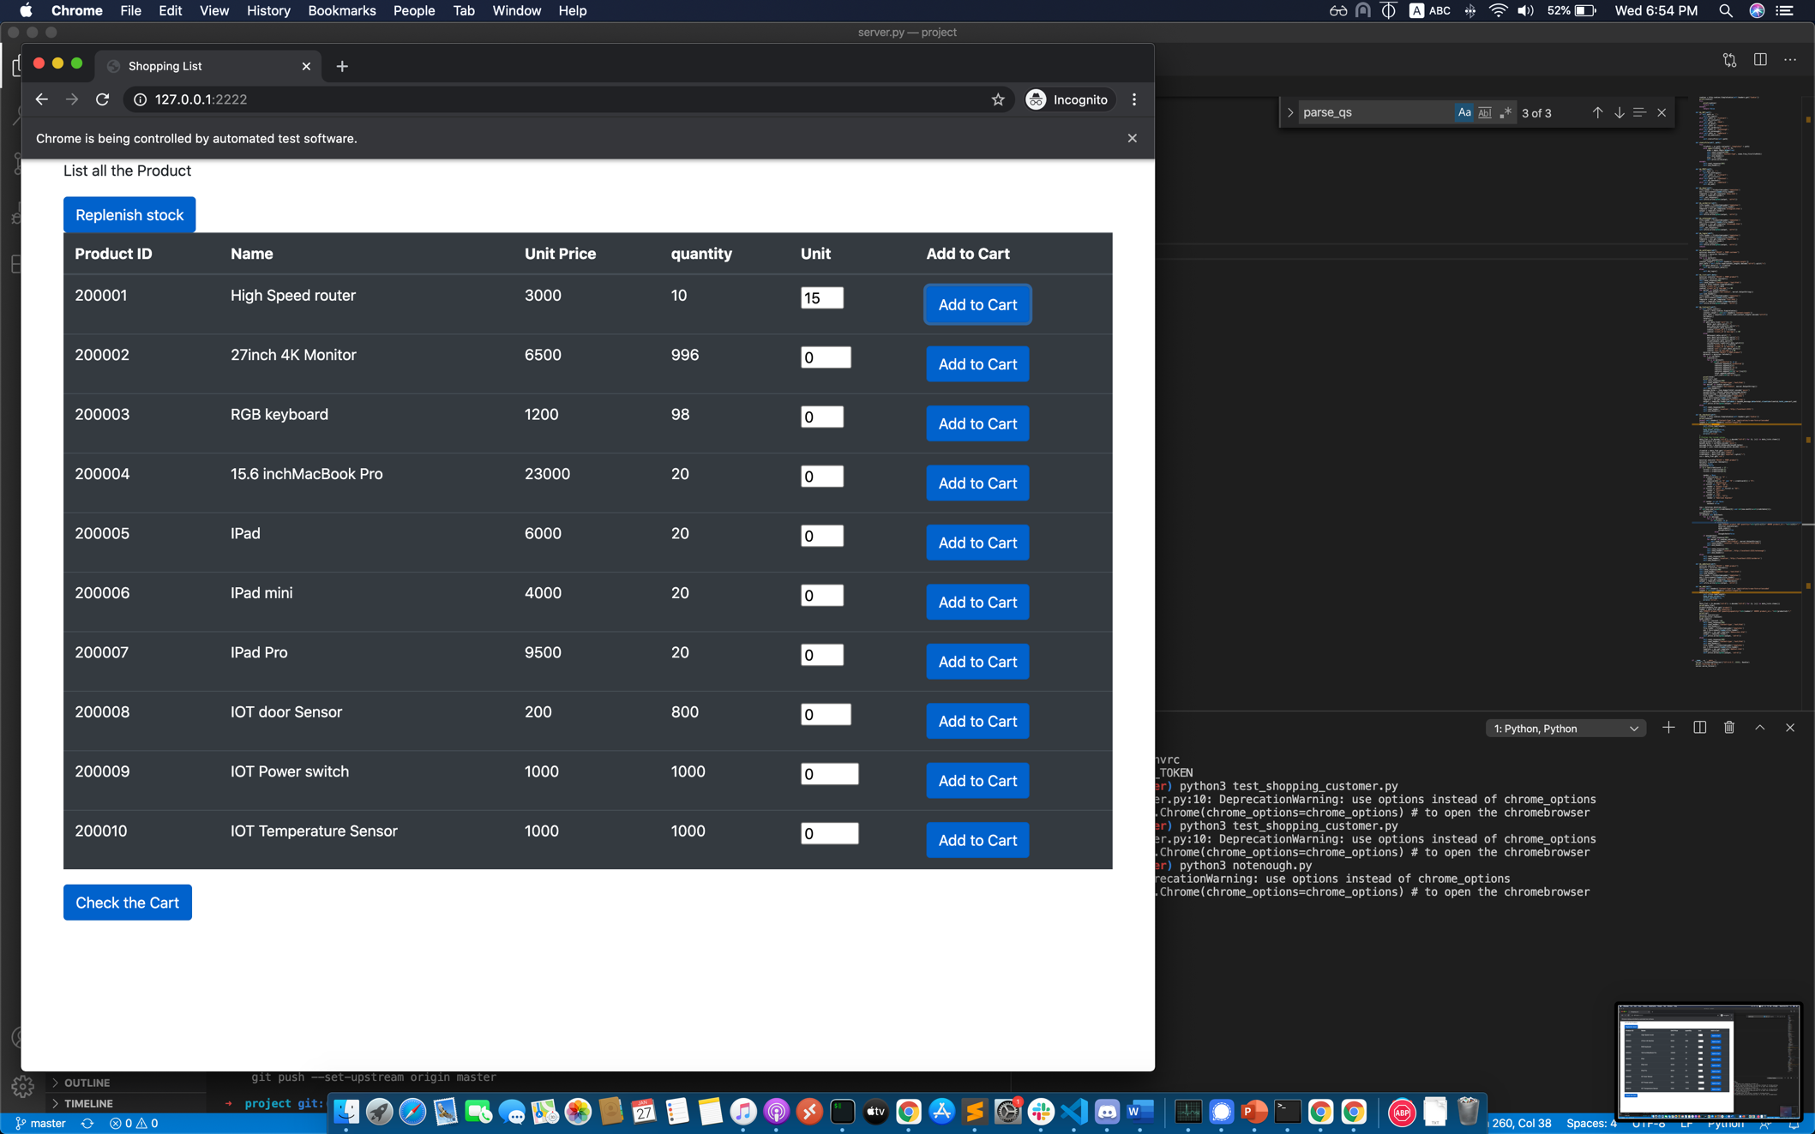

After clicking the check out button.

It will show the cart detail

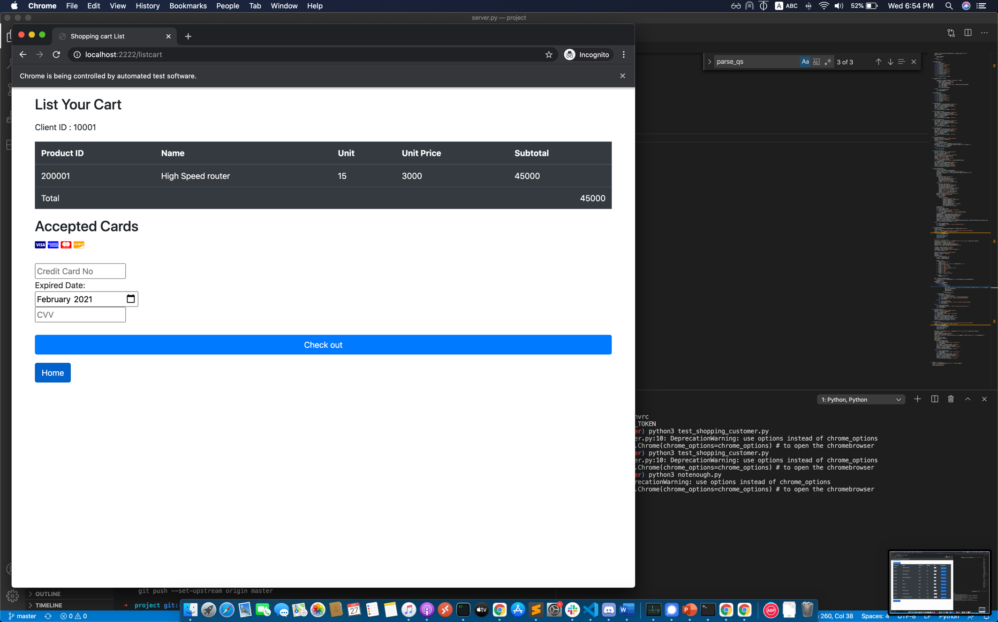

After clicking the check out button

Because of not enough stock, it will return the not enough message to client.

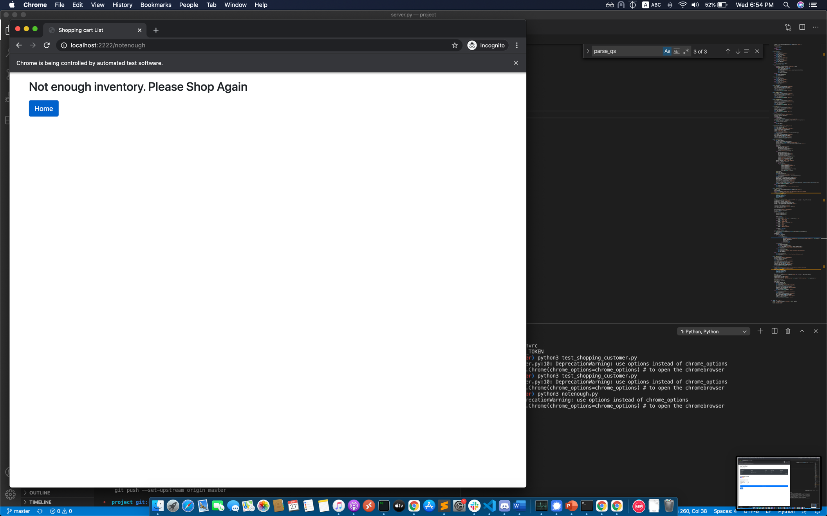

Replenishing the stock and buy successfully

Run the replenish_test.py

Login

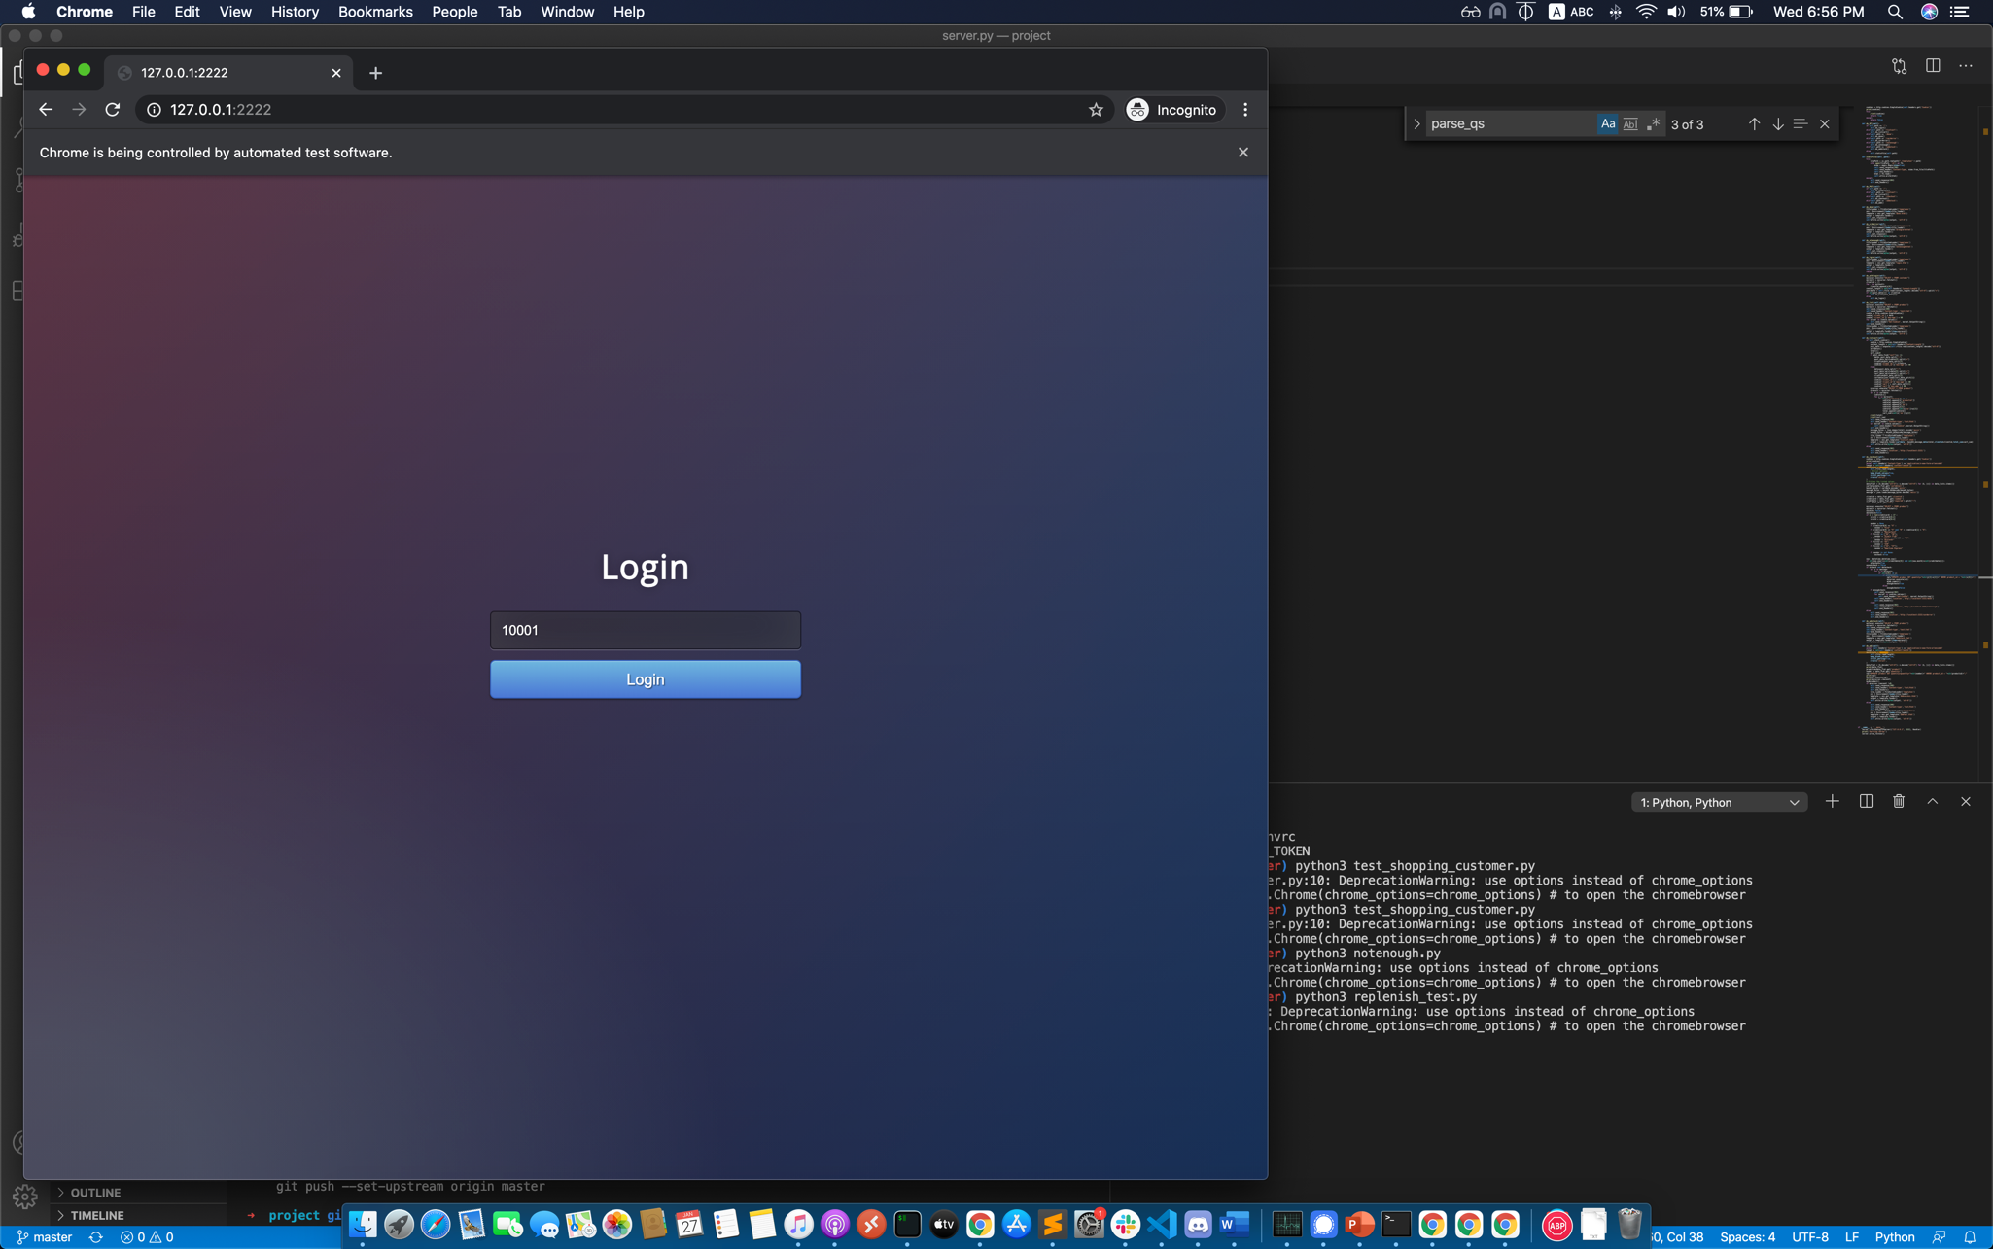

Click the replenish button

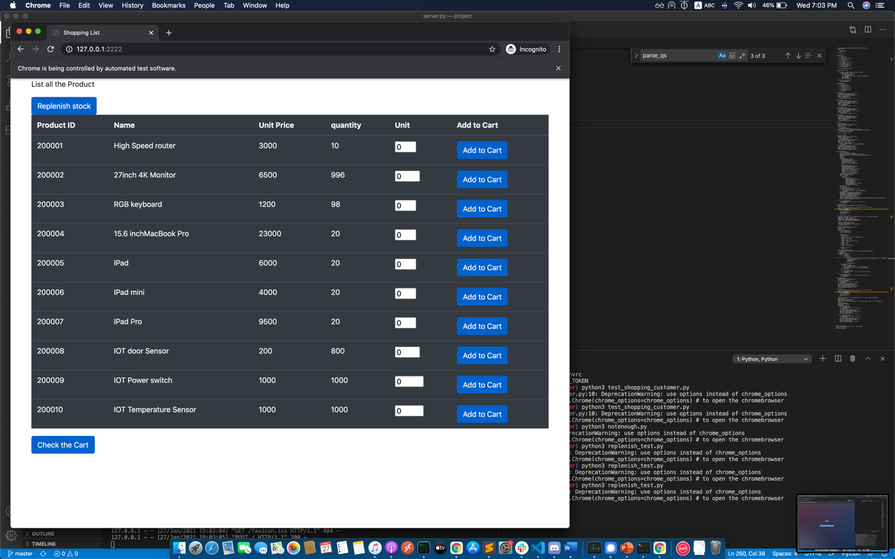

Input the number to add.

And select the product

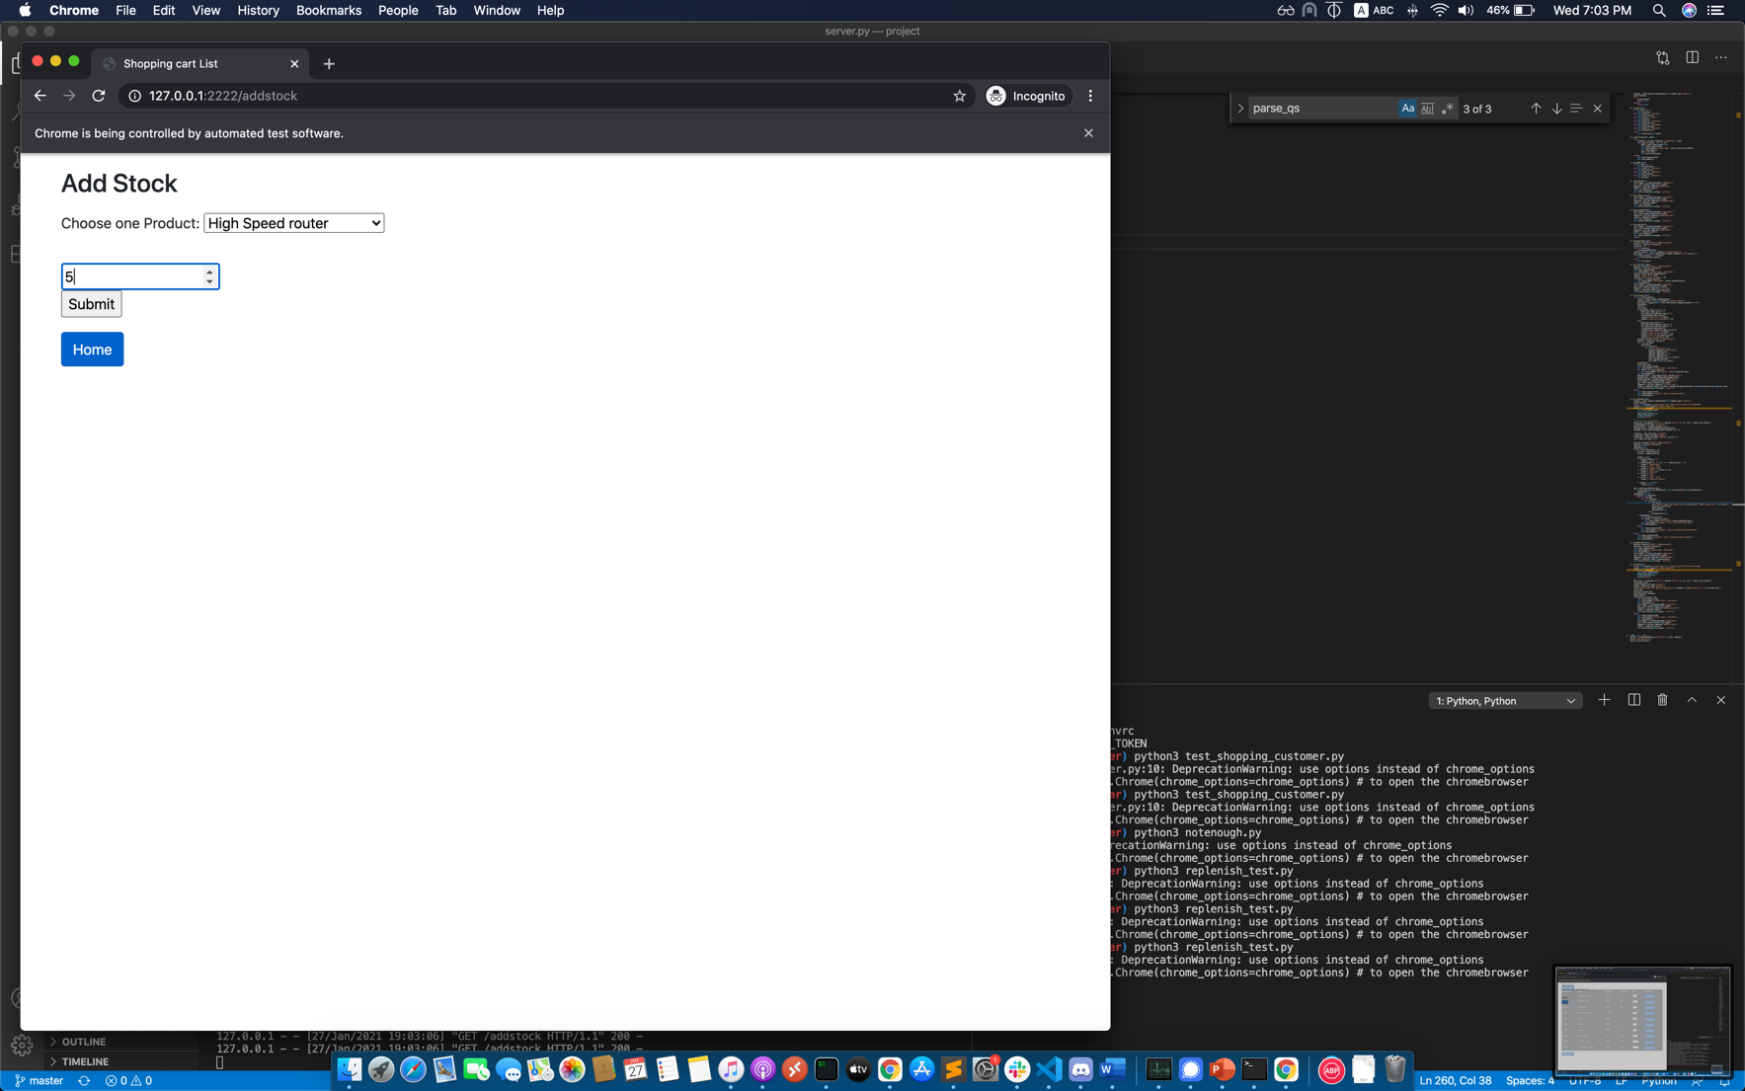

Click submit to add the number of stocks

If success, it will return the success message.

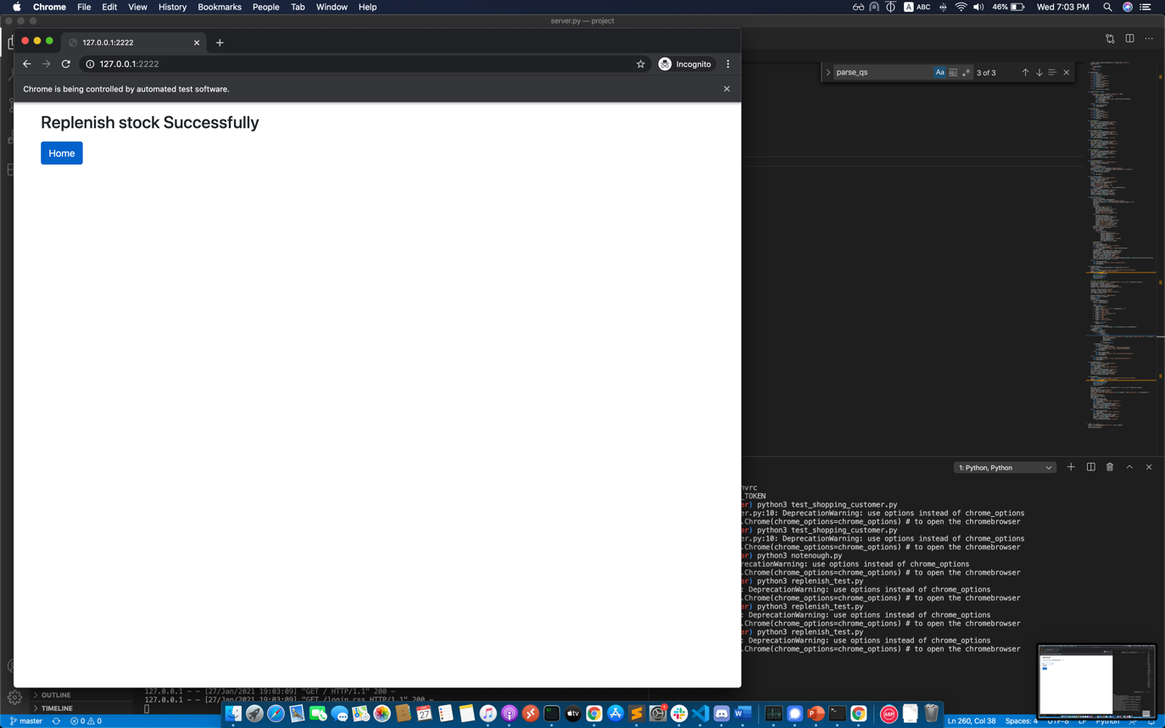

Login again

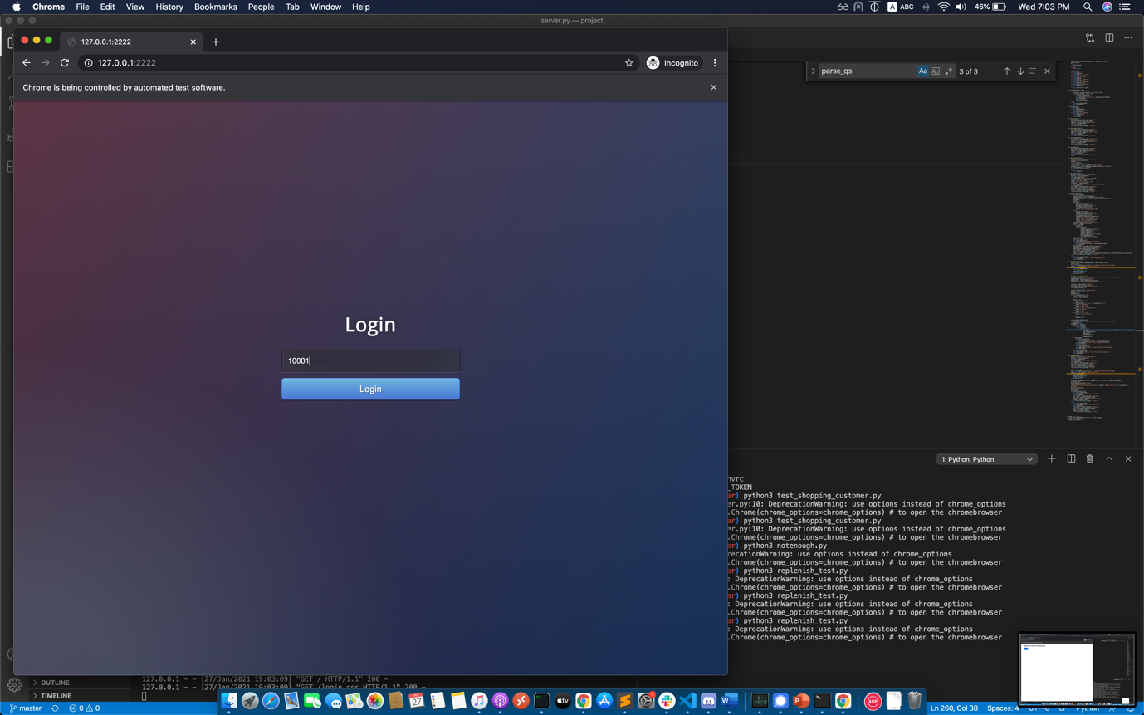

Input 15 into the first product input box

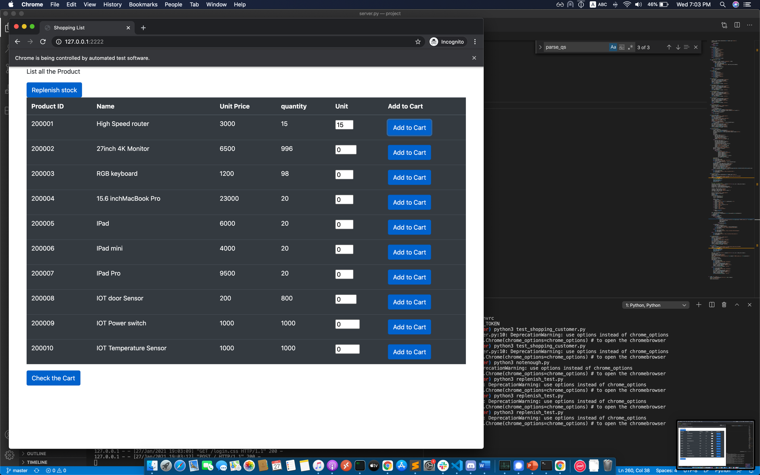

Click the check the cart button

Input the detail of credit card

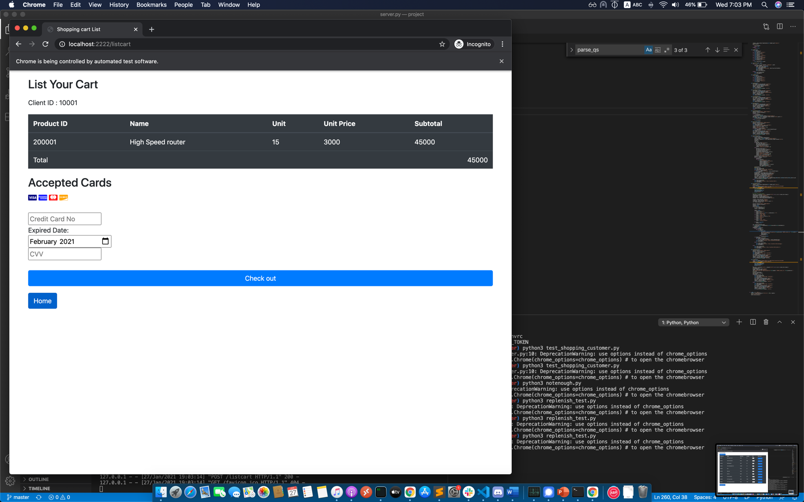

If the checking of the credit card is true, it will return thank you message.

That’s mean the bill success.

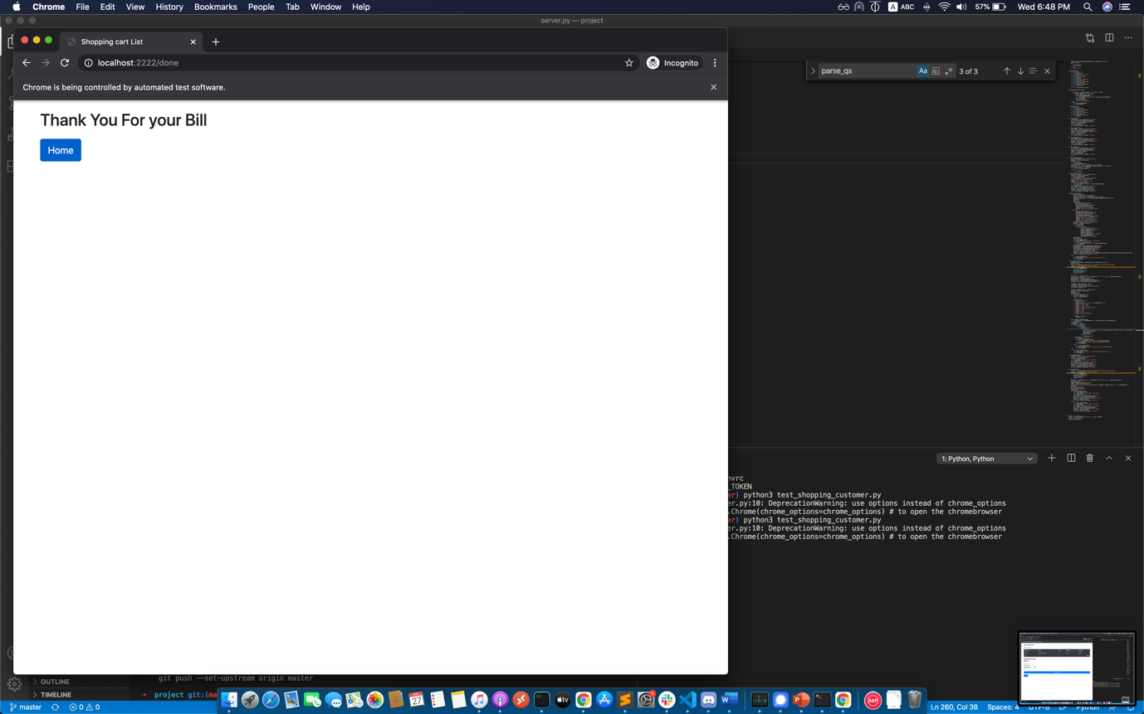

And press home button and go to login page.

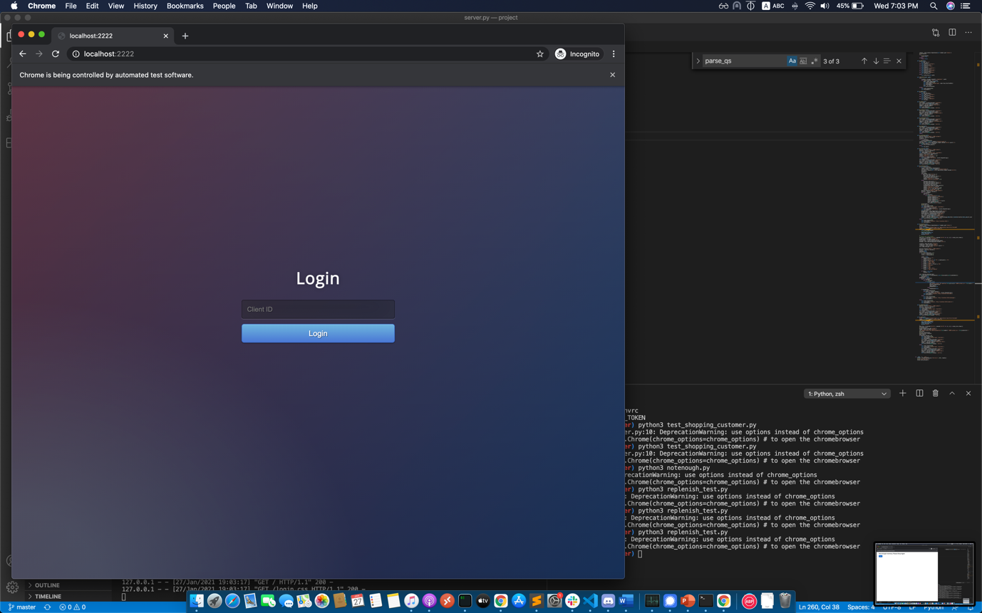

Reflection on project:

In this project, I feel it is very challenging. Using TCP server and threading to develop the http server is not an easy job. Doing research and review the notes is very important on developing the server. Many skills and concepts can be found in the notes.

TCP threading server need to do all the things without library. It needs to handle anything one by one. It is quite different from bottle and flask which are the module within most of the functions. Most of the function is built in the module. Such as the bottle templates tpl. It can render the template into html file. However, the TCP server does not have this kind of library and module. I need to find a module for rendering the html template and learn how to use. Comparing which one html rendering module is one of the tasks on developing the TCP threading server. The header needs to read and decode by myself, there has not any build-in function to help you for decoding the message, the post data, the cookies data, the content type and the file from request.

But I think it is a good try and project. This project can let us to do the research by myself and consider which one module or library is better in our case. It is a good training for our programming skills and cogitation. Depending on different situation and requirement, which function performs well in your project. It is very important question for every programmer. Therefore, I can do better and better from each project and exercise.

Reflection on Learning experience:

In my learning experience, the exercise and the material on the lesson is very useful for my programming life. The exercise and the material can strengthen my foundation. As a programmer, the foundation and cogitation are very important. If doesn’t having this kind of important classes, I will totally feel lost on do this project. On the lesson, we can have a try to practice different technique and do a sharing or discuss with the partner. Deeply understanding is a powerful weapon which can reduce your time and perform well on stress test and resource test.

We learnt the knowledge from the lesson. The knowledge can strengthen out foundation. Also, we need to learn more and become more professional. We need to try more different things with different method. If you do not have a try for the new things or challenging project, you will not get improvement. So, I learn the bottle on the lesson. I want to learn more and try more. That’s why trying to do the project with HTTP TCP threading server. Keeping challenge myself.

Thank you! Oliver.